Module 6

1. The information stored in a general log file is a record of what MySQL is doing. If no name is specified to the general query log the default name is host_name.log and is found in the data directory

2. A system variable is a variable that stores information about the running package and objects. A status variable shows information about a MySQL operation. You view system variables by the command ‘SHOW VARIABLES’. To show status variables you have to use the command ‘SHOW [GLOBAL | SESSION] STATUS’. The system variable I picked was admin_port. Its function is the TCP or IP port number to use for connections on the administrative network. Although you have to set admin_address has to be specified or else admin_port has no effect.

3. Privileges tell what actions a MySQL account can perform. An example of a role is 'update_orders' which was assigned to Jamie. Roles are just ways to allow authentication. Some of the privileges in a small business would be object privileges like execute, select, insert, update, and delete.

1

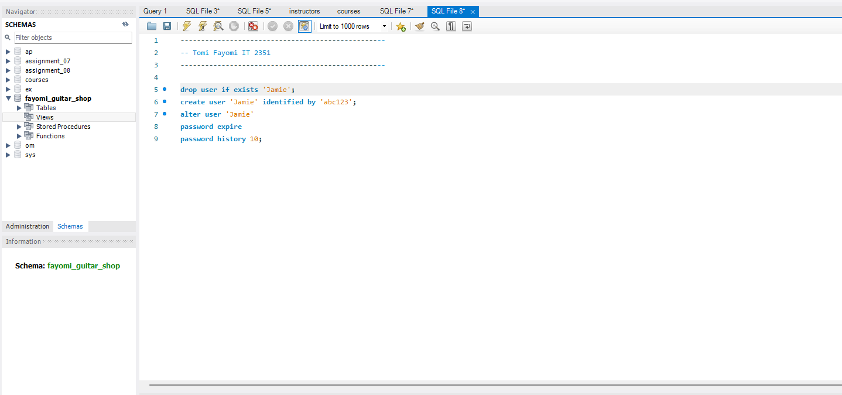

2

